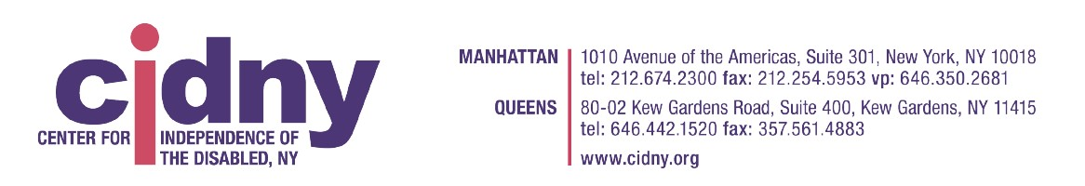
HEALTH CARE ADVOCATE / ATTORNEY
Salary: $76,000
About Us:
The Center for Independence of the Disabled in New York (CIDNY) is the leading organization serving and representing people with disabilities in New York City. CIDNY's mission is the removal of barriers to full integration of people with disabilities. CIDNY helps people with disabilities to gain the skills and obtain the services they need to live independently in the community and advocates for fair and effective policies that improve the quality of life for people with disabilities. CIDNY is an Equal Opportunity Employer.
General Description:
The Health Care Advocate / Attorney will assist seniors and people with disabilities as they transition into and navigate Medicaid Managed Long-Term Care (MLTC). The advocate will be part of the Independent Consumer Advocacy Network (ICAN), the New York State Ombuds program for Managed Long-Term Care. The advocate will work with consumers to resolve issues with their MLTC plans.
Reports to: ICAN Senior Healthcare Advocate and Director of Consumer Services
Duties and Responsibilities:
- Through ongoing direct communication, provide consumers with assistance, advocacy, and education for MLTC plan participants/caregivers by explaining processes relating to enrollment and disenrollment, benefits, coverage and access rules and procedures, member rights and responsibilities, and appeals.
- Explain the grievance and appeals process and assist participants/caregivers in resolving problems and issues using skilled negotiation techniques. Provide assistance in filing grievances and appeals when informal problem resolution proves unsuccessful.
- Assist participants/caregivers with raising and resolving quality of care & quality of life issues
- Communicate extensively with medical professionals, as well as social workers, care managers and administrators at various health facilities and insurance companies.
- Assist participants/caregivers with accessing records from the MLTC plans.
- Answer a live legal helpline for new consumers during assigned shifts.
- Comply with all legal requirements established by NY State Department of Health for obtaining consent, ensuring access to records, coordinating contacts with plans, coordinating referrals, and ensuring confidentiality, and protect against inappropriate disclosures of identifiable information.
- Ongoing research of relevant NY State laws and regulations as related to any/all issues that arise for participants/caregivers’ concerns.
- Ensure all significant client data and service provision details are current and accurate, and that they are documented in a timely manner into CIDNY’s, as well as contracted provider’s databases.
- Maintain established quality assurance procedures. Conduct quality assurance reviews of cases, using case notes and information reports in the database.
- Provide consumer outreach and education presentations at other community-based organizations and to participants/caregivers and advocates. Assist with developing and maintaining an outreach and education campaign.
- Attend Agency’s in-service training and unit meetings as well as any other agency-wide related activities. Conduct trainings regarding client education, navigational and appeal services, consumer rights and responsibilities.
- Identify systemic trends or practices that affect people with disabilities and seniors and work closely with other stakeholders to design a systemic response.
- Assist in preparation of reports concerning the program.
- Other responsibilities as identified by Supervisor
Qualifications:
Education and/or experience required:
- JD or master’s degree in relevant field (e.g. public health, public policy, social work) strongly preferred; Bachelor’s required.
- Education and/or experience in social service law and policy, especially as related to Medicare and Medicaid, strongly preferred.
- Demonstrated experience providing assistance to people with issues relating to health insurance / health care access.
- Previous work with the disability and/or elder community, or personal experience, a plus.
Skills, Licenses, and/or competencies required:
- Excellent advocacy, interpersonal, organizational, and communication skills required
- Excellent time management skills to maintain caseload, documentation and administrative requirements, and individual/community outreaches
- Familiarity with health care coverage information, eligibility rules, and resources
- Understanding of social service delivery system and government/benefits resources, including law and policies related to Medicare and Medicaid
- Must be computer literate of basic Microsoft programs, including Outlook and Word, as well as familiarity with Adobe Acrobat
- Ability to work well independently as well as part of a team
- Respectful and comfortable with people from different cultural and socio-economic backgrounds; familiarity with Americans with Disabilities Act preferred.
- Bilingual preferred.
Position Specifics:
- Location: Manhattan Office.
- Salary: $76,000 annually.
- Hybrid Schedule (Three days per week must be client-facing).
- Monday – Friday.
- Benefits available: Medical, paid time off, Sick pay, Paid holidays, Dental, Life insurance, Vision, and 403B plan.

Other Information:
We confirm to all laws, statutes, and regulations concerning equal employment opportunities and affirmative action. We strongly encourage women, minorities, individuals with disabilities and veterans to apply to all of our job openings. We are an equal opportunity employer, and all qualified applications will receive consideration for employment without regard to race, color, religion, gender, national origin, disability status, genetic information and testing, family and medical leave, sexual orientation and gender identity or expression, protected veteran status, or any other characteristic protected by law. We prohibit retaliation against individuals who bring forth any complaint, orally or in writing, to the employer or the government, or against any individuals who assist or participate in the investigation of any complaint or otherwise oppose discrimination.
How to Apply:
Please send a thoughtful cover letter, and resume to Nina Kravetz, ICAN Senior Healthcare Advocate at nkravetz@cidny.org. Please use the job title as the email header. The cover letter should include your work history and other relevant life experiences, and it should clarify what transferable skills you bring to the posted job description.
No application will be considered without this cover letter.

