Our Queens Office is Moving—Same Building, Different Floor
CIDNY Queens is growing so we needed newer and bigger office space to accommodate new staff and new services. On September 1, 2017, the CIDNY Queens office at 80-02 Kew Gardens Rd Suite 107, is moving to the 4th floor in the same building: Suite 400. We will continue to provide the same services as in the past:
· Benefits Advisement/Checkup
· Housing information
· Health care
· Peer counseling
· The Ombudsmen program
· Youth Program
· SNAP
· HASS program

Our new office will offer new programs through new staff:
· The Olmstead Housing program
· FHA program
· New York Connects Queens program
We look forward to continuing to serve the Borough of Queens. Come visit us!

New Program at CIDNY: NY Connects

CIDNY hired 23 new staff members to complete our NY Connects team. The NY Connects team includes: a program director, an education and training coordinator, one program support, four borough managers, an outreach coordinator, two outreach workers, and 13 benefits counselors. They speak 12 languages other than English. These include: Spanish, Greek, Arabic, ASL, Vietnamese, Haitian Creole, Portuguese, Urdu, Hindi, Punjabi, Bengali, and Romanian. The staff identify with several disabilities, including but not limited to: learning disabilities, visual, hearing, and physical disabilities. Their backgrounds include: law, social work, human services, outreach, counseling, education, and emergency management.

CIDNY’s NY Connects Program’s goal is to link disabled New Yorkers with the resources to help meet their long term care needs. Benefits counselors will offer peer-centered counseling and connect disabled New Yorkers in each borough to local services and programs. They help participants make informed decisions. They can assist in accessing available services and support options that meet existing or future long term needs.
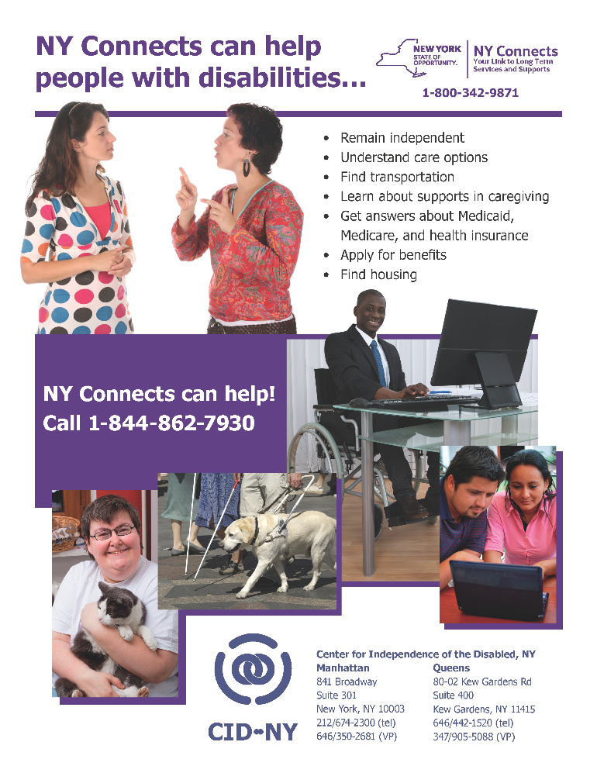
CIDNY’s NY Connects partners with several ILCs throughout the city so we can have a physical presence in every borough. We also partner to get the word out about what NY Connects can do to serve the disabled population in our city.

CIDNY’s NY Connects is a trusted service to get free information about the range of supports that can help a person with disabilities (PWD) remain independent. This is available whether they want to live in their home, a nursing home, or other residential setting.

Launching on September 1st 2017, the NY Connects benefits counselors can be reached at 844-862-7930.

Individual Voter Survey
The Mayoral Primary Election is being held on September 12, 2017. CIDNY staff and volunteers will be surveying more polling sites to see whether the Board of Elections has made more of them accessible. You can help. After you vote, please complete CIDNY’s Individual Voter Survey online here:
https://www.surveymonkey.com/r/FK5QXY9
Your help in the past has identified problems at polling sites. With your help this election, we can continue to let the City Council and the Board of Elections know about problems that still need to be fixed.
Every voter experience that we can document—including the good ones—makes a difference in our efforts to improve our election process! If you need help completing the survey, please call Monica Bartley at 646-442-4152.
Election Dates 2017
We encourage everyone to get out and vote. We need to be seen and heard so that our concerns are taken seriously. The Mayor, City Council, Public Advocate and Comptroller all have a say in issues like curb cuts, poll site access, Access-a-Ride, subways, and buses. Let them know we are active, we vote and we are watching what they say and do.
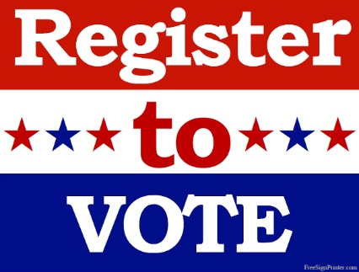
If you have not registered to vote, the deadline has passed for the primary election in September. You can still register for the November general election. Deadlines below.
Primary Election September 12, 2017
Offices up: Mayor, City Council, Public Advocate, and Comptroller

General Election November 7, 2017
Offices up: Mayor, City Council, Public Advocate, and Comptroller
- October 13 - Mail Registration for General Election: Last day to postmark application for registration for general election. The last day it must be received by board of elections is Oct. 18.
- October 13 - In person registration for General Election: Last day application for registration must be received by board of elections to be eligible to vote in general election. If honorably discharged from the military or have become a naturalized citizen since October 13th, you may register in person at the board of elections up until October 28th.
- October 13 - Last day for change of party enrollment.
- October 18 - Last day for change of address.

If you have internet access, you can also register to vote or change your address for your registration online through the NYS Department of Motor Vehicles website: https://dmv.ny.gov/more-info/electronic-voter-registration-application). To use the DMV site, you must have a driver’s license or a non-driver ID.

If you need help registering to vote or changing your address, please contact Monica Bartley - mbartley@cidny.org or 646-442-4152. You can also contact your CIDNY benefits counselor who can help you.

Curb Cuts – a Great Report by the Court’s Special Master
This August the Special Master appointed by Federal Judge Daniels delivered his assessment and recommendations from his review of the proposed settlement on curb cuts. CIDNY, among other organizations, had objected to the settlement because it did not require the City to establish and meet deadlines, did not provide specific direction on complying with the Americans with Disabilities Act (ADA), and did not provide any monitoring or consequences to ensure that the City complies with any settlement and the ADA. We provided testimony to the court to object to the settlement, and provided our surveys and your statements of concern.
This is a great win for our community. In twelve recommendations, the Special Master agreed with all of our objections to the proposed settlement and recommended resolutions that we agree with. It is now up to Judge Daniels to review the report and to accept some or all of the Master’s recommendations. For the Special Master’s report and our press release, go to our website’s home page, www.cidny.org.
We thank all of you who joined us in telling the court why the settlement won’t work. We will be watching for Judge’s decision in the coming months and let you know what his decision is.

NEED HELP?

Walk in to get the help you need. Staff will be available during these times for housing and benefits-related help.



Walk-In Days—Manhattan
Every Monday and Tuesday, 10:00 am to 1:30 pm Every Thursday from 10:00 am to 3:00 pm
Walk-In Day—Queens
Every Monday 10:00 am to 3:00 pm

CIDNY ACTION NETWORK MEETING
Wednesday, September 13, 2017
CIDNY-Queens office
1:00-3:00 PM

Come Join Us and:

Tell us about your voting experience in the September Primary and complete the Individual Voter Survey.

We will prepare for our visits to the District offices to tell our legislators about our issues of concern.
Please RSVP to Eva Eason at (646) 442-4156. If you need an accommodation, such as large print or ASL or language interpretation services, please let us know by Wednesday, September 6, 2017.

Refreshments will be served.

Housing Workshop - Queens
Wednesday, September 27th, 10:00 am to noon.
CIDNY’s 2-hour housing workshop covers: housing options: NYCHA, HPD, HUD listings; NYC Housing Connect and other programs; what you qualify for; in-come and family size; and how to get and go over your credit report.

Space is limited: 646-442-1520 to reserve your spot. Also, let us know if you need an accommodation like American Sign Language or large print.
 CIDNY’s Writers’ Group

For the month of September, on Thursdays, the 7th, 14th, 21st and 28th, the group will meet at the LGBT Center at 208 West 13th Street (just west of 7th Avenue), room 304 from 3:30 to 5:30pm. The writers’ group is a facilitated, non-judgmental writing group that promotes individual expression and creativity in a supportive atmosphere. If you are interested in joining the group, please contact Eva Burgess at 212-674-2300.

Movie night is on hiatus. We will resume in the fall. Watch the calendar for updates.

All events are at CIDNY, 841 Broadway, Suite 301, New York, NY 10003 unless otherwise stated. To RSVP for events, contact Eva Burgess at 646-442-4156 or eeason@cidny.org.
If you need an accommodation, please let Eva know. For ASL interpreters, let us know one week in advance. We cannot guarantee accommodations like ASL interpreters if we do not have advanced notice.

Sun |  | Mon |  | Tue |  | Wed |  | Thu | Fri |  | Sat
 | 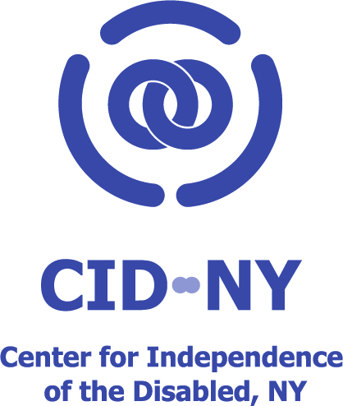 |  |  |  |  |  | Walk-in Day  10:00 am - 3:00 pm   Writer’s Workshop 3:30 pm to 5:30 pm |  |  | 1   |  | 2
3 | 4  Office Closed for Labor Day   |  | 5  Walk-in Day  10:00 am – 1:30 pm |  | 6 |  | 7  Walk-in Day  10:00 am - 3:00 pm  Writer’s Workshop 3:30 pm to 5:30 pm |  |  | 8 |  | 9
10 | 11  Walk-in Day  10:00 am to 1:30 pm  Walk-in Day - Queens  10:00 am - 3:00 pm |  | 12  Walk-in Day  10:00 am – 1:30 pm |  | 13 |  | 14  Walk-in Day  10:00 am - 3:00 pm  Writer’s Workshop 3:30 pm to 5:30 pm |  |  | 15 |  | 16
17 | 18  Walk-in Day  10:00 am – 1:30 pm  Walk-in Day - Queens  10:00 am - 3:00 pm |  | 19  Walk-in Day  10:00 am – 1:30 pm |  | 20   |  | 21  Walk-in Day  10:00 am - 3:00 pm  Writer’s Workshop 3:30 pm to 5:30 pm |  |  | 22 |  | 23
24 | 25  Walk-in Day  10:00 am – 1:30 pm  Walk-in Day - Queens  10:00 am - 3:00 pm |  | 26  Walk-in Day  10:00 am – 1:30 pm |  | 27    Queens Housing Workshop  10:00 am – 12:00pm |  | 28  Walk-in Day  10:00 am - 3:00 pm  Writer’s Workshop 3:30 pm to 5:30 pm |  |  | 29 |  | 30

