Our New Website Launched
We are pleased to announce that the new CIDNY website (www.cidny.org) is live!
We hope that you will enjoy the new design and features. We think that it will make it easier to find the information that you are looking for.

Site Navigation. We have reorganized the content and look of the site. There are now multiple ways to access the content that you need and there are more visuals and other breaks in the text. We included more icons for people with low English language literacy to be better able to access information and services.

Fresh Content. Our site now features more images, our social media feeds, a new blog, and updated content so that you can better understand what we’re up to and engage with us.

Accessibility. We created the site using Web Accessibility Initiative (WAI) guidelines. All of the images have alt text for screen readers. Our staff has done multiple rounds of testing of the site on desktop computers, mobile devices, and in JAWS screen reader, MAGic screen magnification software, and ZoomText magnifier and screen reader. If you encounter any issues or need a document on the site in an alternate format, please don’t hesitate to contact us at info@cidny.org.

Translation. We included a Google translate widget so that pages can be translated into other languages, including the 23 languages other than English that are spoken by our team.

Search. You can now search throughout the website for the information and resources that you need.

Tell Us What You Think. Please take a moment to complete our feedback survey (https://www.surveymonkey.com/r/Q2DXGD7) so we can continue to make our site more valuable for our visitors.
CIDNY Action Network (CAN)

CAN is a group of people with disabilities, their friends, and their families who come together to protect our rights. We learn strategies for self-advocacy to effect societal change. We write letters, make telephone calls, and meet with legislators to get policies and laws enacted that benefit people with disabilities. We advise on upcoming policy issues and their effect on people with disabilities. We work together on policy agendas to present to our local and state policy makers. And, we take action.

Recently, CAN members joined a protest, “STOP THE ZOMBIE REPUBLICAN HEALTH CARE BILL!” This bill would have meant cuts in Medicaid and Medicare that would affect our ability to get the healthcare we need. We also sent letters and called our U.S. senators to tell them how the bill would affect us.
We make presentations to educate the public about our needs and attend hearings to make our positions known. For example, we spoke about the need for elevators at all subway stations and the need for better maintenance of existing elevators at the recent MTA Capital Budget Hearing. We submitted testimony to the Taxi and Limousine Commission regarding a proposed rule change.
We have had a lot of victories in the last two years (see CIDNY’s Annual Report at https://cidny.org/annual-reports/). Join us to keep our track record of success going. There are many issues ahead where our voices need to be heard to make sure our rights are secure.
Get involved by joining CAN. You can help us make a difference. Your voice will be added to others in New York to enforce rights for people with disabilities. CAN meetings are held monthly and alternate between our Manhattan and Queens offices. Please contact Monica Bartley at 646-442-4152 or mbartley@cidny.org for additional information.

Election Dates 2017
We encourage everyone to get out and vote. The Mayor, City Council, Public Advocate, and Comptroller all have a say in issues like curb cuts, poll site access, Access-a-Ride, subways, and buses. Let them know we are active, we vote, and we are watching what they say and do.
If you have not registered to vote, you can still register for the November general election. Deadlines for registration are:
General Election November 7, 2017
Offices up: Mayor, City Council, Public Advocate, and Comptroller
October 13 - Mail Registration for General Election: Last day to postmark application for registration for general election. The last day it must be received by board of elections is Oct. 18.
In person registration for General Election: Last day application for registration must be received by board of elections to be eligible to vote in general election. If honorably discharged from the military or have become a naturalized citizen since October 13th, you may register in person at the board of elections up until October 28th.
Last day for change of party enrollment.
October 18 - Last day for change of address.

If you have internet access, you can also register to vote or change your address for your registration online through the NYS Department of Motor Vehicles website: https://dmv.ny.gov/more-info/electronic-voter-registration-application. To use the DMV site, you must have a driver’s license or a non-driver ID.
If you need help registering to vote or changing your address, please contact Monica Bartley at mbartley@cidny.org or 646-442-4152. You can also contact your CIDNY benefits counselor who can help you.

Youth Transitions Program: Preparing for the Future
CIDNY’s youth transition program for youth with disabilities helps high school or college students plan their transition into adult life. We use the Next Step program, a six to nine week curriculum to teach students the soft skills needed for success. These include effective communication, managing a budget, and how to advocate for themselves as they continue on to college and the working world.
In the 2016-2017 school year, we delivered the Next Step program workshops to 111 youth with disabilities in nine different high schools, including a residential school in Queens. We also helped 18 college students at two Queens area colleges. With the help of ASL interpreters, the Next Step program was also delivered to a group of six Deaf students during the summer.
Learn more on our blog at: https://cidny.org/youth-transitions-program-preparing-for-the-future/.

Purpose, Progress, Power: New Strategies for Systemic Change

In mid-September, many CIDNY staff members and volunteers attended the New York Association on Independent Living’s (https://ilny.us/) annual conference. We shared resources and information, learned about different issues, and connected with other independent living centers around the state.

CIDNY staff presented workshops on using stories to motivate action, the fight to preserve and improve health care for people with disabilities, peer advocacy as a strategy for resistance and change, health plan network adequacy, and achieving systems change through legal action.

The Open Doors team learned about how to effectively work with participants regarding grief during their move from a nursing home to the community as well as the varied benefits available to those who have served in the military. The Open Doors team also learned about Managed Long Term Care and services available to those who are users of OPWDD services.

Disability rights advocate Judy Heumann spoke at the conference and interviewed our executive director and community outreach organizer for her YouTube series (https://www.youtube.com/channel/UCB7pemkbDQYezB6PeDFXTvg), the Heumann perspective. Policy expert and former Obama Administration inclusion team member Rebecca Cokley also spoke. She discussed the disability rights movement and working with other social movements around race and LGBTQ issues because of shared values. She also reminded us about the importance of self-care and having fun. Overall, it was a good event!

NEED HELP?


Walk in to get the help you need. Staff will be available during these times for housing and benefits-related help.



Walk-In Days—Manhattan
Every Monday and Tuesday, 10:00 am to 1:30 pm Every Thursday from 10:00 am to 3:00 pm
Walk-In Day—Queens
Every Monday 10:00 am to 3:00 pm

CIDNY Offices are closed Monday, October 9.


CIDNY CAN

Wednesday, October 18, 2017, 1:00-3:00 PM

Join us for a film screening of "Bottom Dollars,"
an hour-long documentary that exposes the exploitation of people with disabilities through personal stories and expert interviews. Nearly 250,000 people are legally paid less than the minimum wage, on average, less than $2 an hour.
It also presents clear employment alternatives with competitive wages and community inclusion. We will have a discussion on the film afterwards. Refreshments will be served.
Please RSVP to (646) 442-4156. If you need an accommodation, such as large print or interpretation services, please let us know by Wednesday, October 4, 2017.

HALLOWEEN PARTY
Join us for CIDNY’s Halloween Party
at the Manhattan office on Tuesday, October 31, from 3:00- 5:00pm – Costumes optional. There will be small pumpkin decorating, some games and refreshments.

Housing Workshop - Queens

Wednesday, October 25, 10:00 am to noon.
CIDNY’s 2-hour housing workshop covers: housing options: NYCHA, HPD, HUD listings; NYC Housing Connect and other programs; what you qualify for; in-come and family size; and how to get and go over your credit report.

Space is limited: 646-442-1520 to reserve your spot. Also, let us know if you need an accommodation like American Sign Language or large print.



CIDNY’s Writers’ Group

This group meets every Thursday at CIDNY’s Manhattan office, 841 Broadway. The writers’ group is a facilitated, non-judgmental writing group that promotes individual expression and creativity in a supportive atmosphere. If you are interested in joining the group, please contact CIDNY at 212-674-2300.

All events are at CIDNY, 841 Broadway, Suite 301, New York, NY 10003 unless otherwise stated. To RSVP for events, contact the receptionist at 646-442-4156 or info@cidny.org.
If you need an accommodation, please let the receptionist know. For ASL interpreters, let us know one week in advance. We cannot guarantee accommodations like ASL interpreters if we do not have advanced notice.

Sun |  | Mon |  | Tue |  | Wed |  | Thu | Fri |  | Sat
1 | 2 |  | 3 |  | 4  Sukkot Starts   |  | 5  Walk-in Day  10:00 am-3:00   Writer’s Workshop  3:30-5:30 pm |  |  | 6 |  | 7
8 | 9  Office Closed for Columbus/  Indigenous People’s Day |  | 10  Walk-in Day  10:00 am–1:30 |  | 11 |  | 12  Walk-in Day  10:00 am-3:00  Writer’s Workshop  3:30-5:30 pm |  |  | 13 |  | 14
15 | 16  Walk-in Day  10:00 am-1:30  Walk-in Day - Queens  10:00 am–3:00 |  | 17  Walk-in Day  10:00 am–1:30 |  | 18  CIDNY CAN  Meeting  1:00-3:00 |  | 19  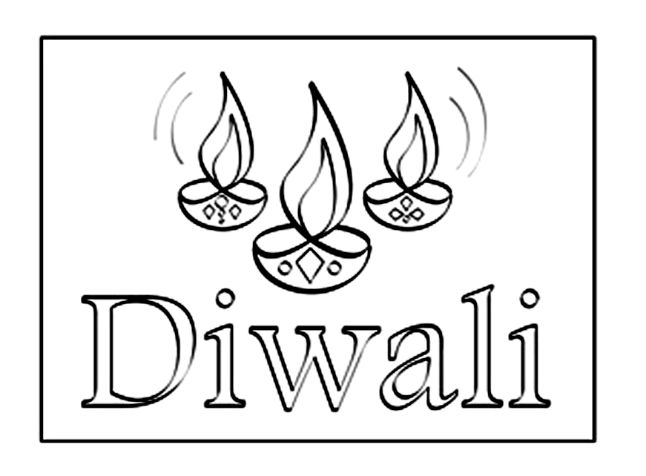  Walk-in Day  10:00 am-3:00  Writer’s Workshop  3:30-5:30pm |  |  | 20 |  | 21
22 | 23  Walk-in Day  10:00 am–1:30  Walk-in Day - Queens  10:00 am-3:00 |  | 24  Walk-in Day  10:00 am–1:30 |  | 25  Queens Housing Workshop  10:00 am–12:00 |  | 26  Walk-in Day  10:00 am-3:00  Writer’s Workshop  3:30-5:30pm |  |  | 27 |  | 28
29 | 30  Walk-in Day  10:00 am–1:30  Walk-in Day - Queens  10:00 am-3:00 |  | 31  Walk-in Day  10:00 am–1:30    CIDNY’s Halloween Party 3:00-5:00 pm |  | 31 |  |  |  |  | 